# GUI

Each group must include mock-ups of the key pages or stages of the system. Explain how they are linked. Explain how you addressed requirements in the design. It is important that the mock-ups are in line with the functional requirements, e.g. one requirement is “user registration” then one of the screens listed in this section should show a registration page. **[20% of Marks]**

1. Customer and Admin Registration Page

This is the registration page for the admin and customer show in the picture.

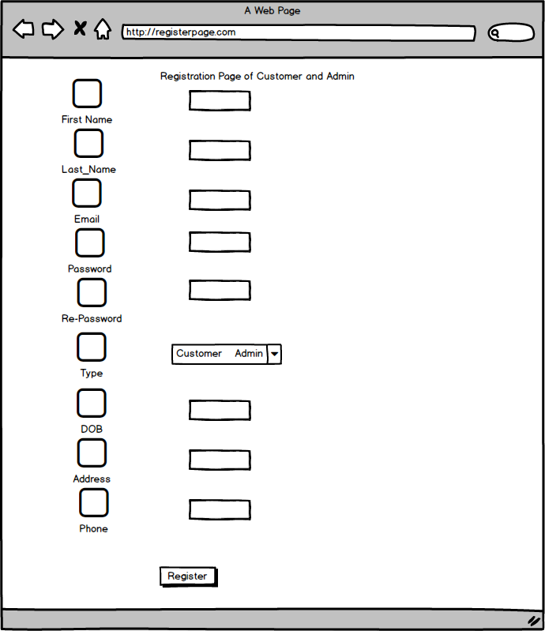

1. Registration Page of Company

This is the registration page of company shown in the picture.

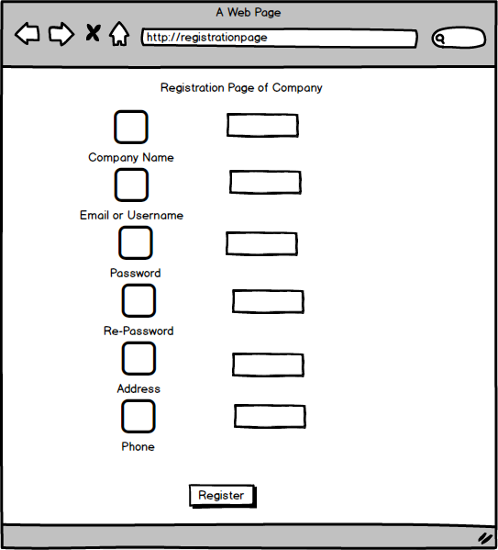

1. Login Page for all users

This is the login page for all the users (Customer, Admin and Company) shown in the picture.

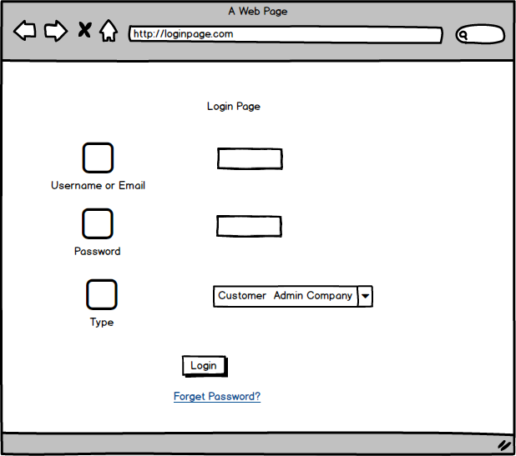

1. Home Page

This is a home page of our website show in the picture which is our first page.

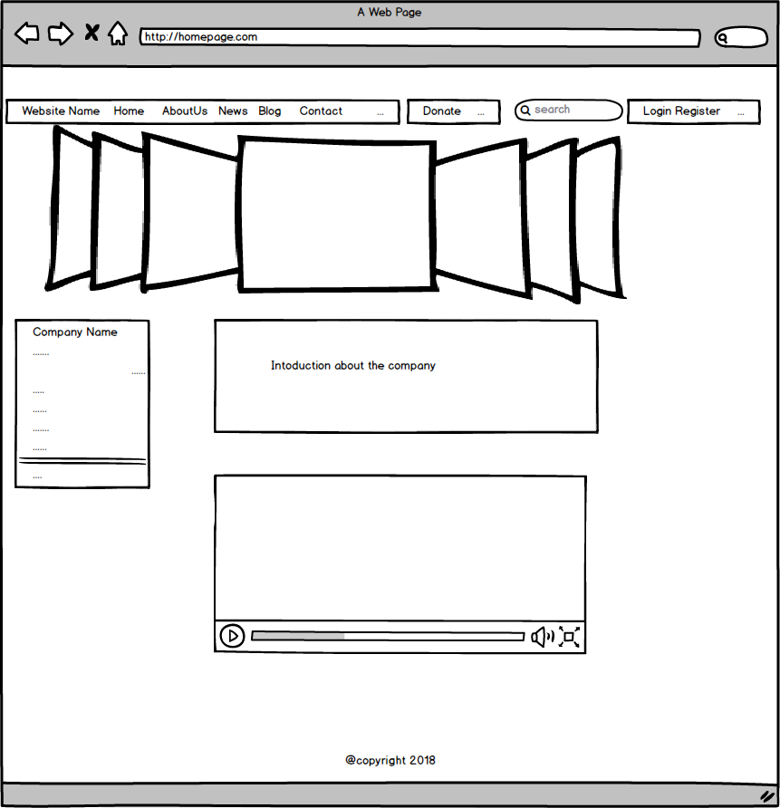

1. About Page

This is the about page shown in this picture.

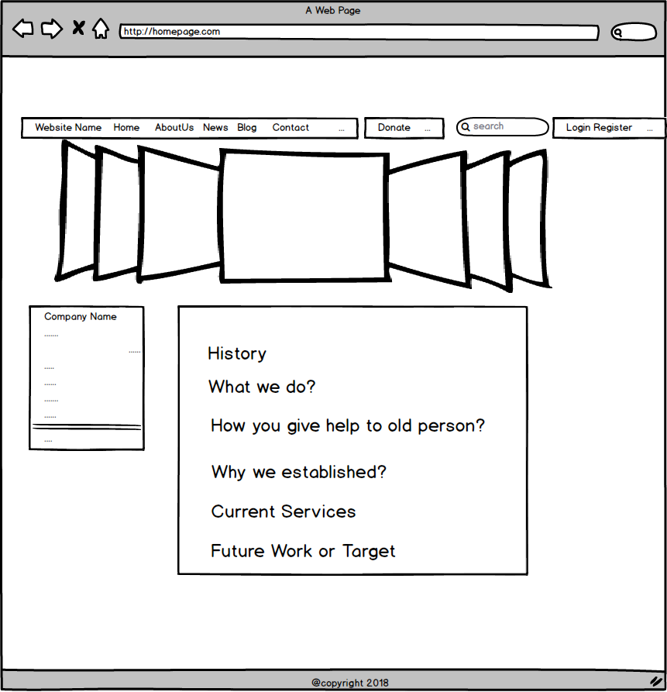

1. New Pages

This is the new pages shown in this picture.

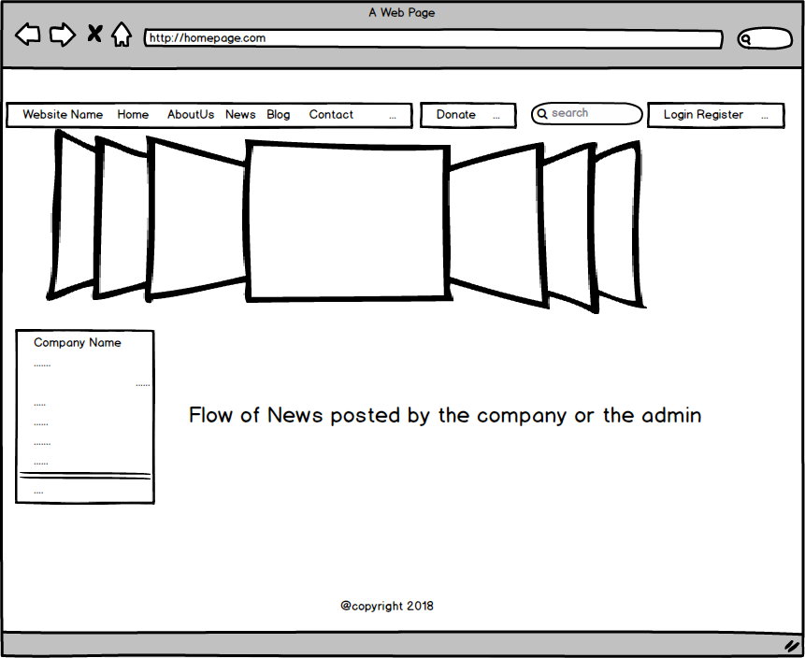

1. Blog Page

This is the blog page shown in this picture.

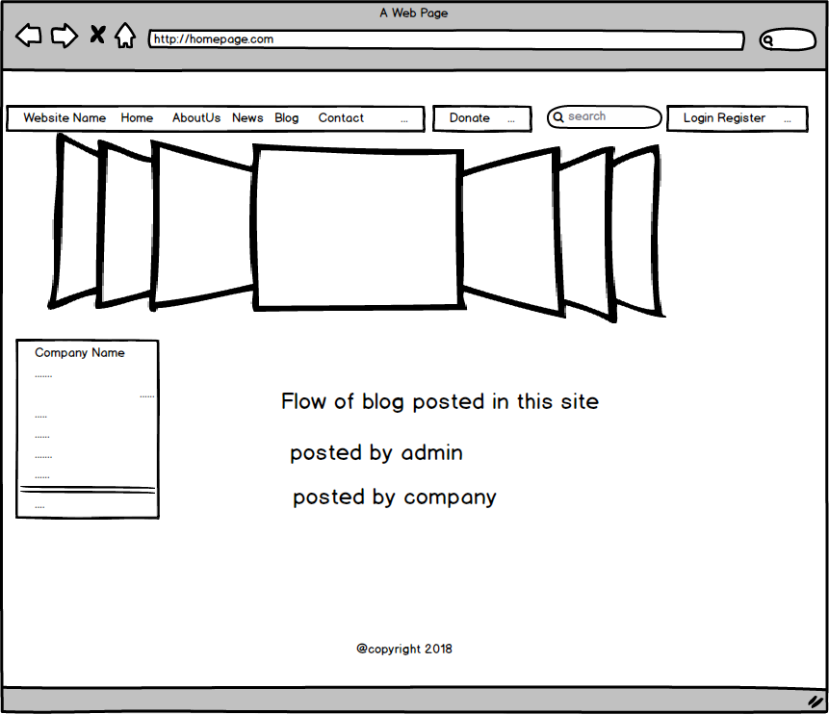

1. Contact Page

This is the contact page shown in this picture.

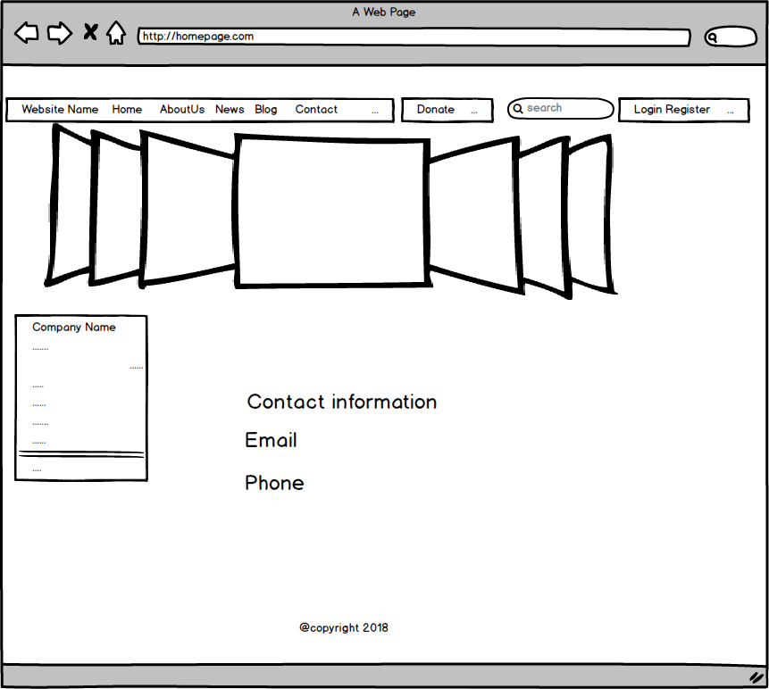

1. After Login Home Page

This is the after login home page shown in the picture.

